
R&D Report on Azure Global Infrastructure

Exploring Azure Geographies, Regions, Availability Zones, and Data Centres

Prepared by:
Virat Pandey

Celebal Technology
Cloud Infrastructure & Security Internship

Research & Development Document




Table of contents

Table of Contents

- Introduction
- Azure Geographies
- Azure Regions
- Availability Zones
- Azure Data Centers
- Global Redundancy and Resiliency Strategy
- Real-World Relevance in Cloud Deployments
- Conclusion
- References



Introduction

Microsoft Azure is one of the most globally distributed and resilient cloud platforms in the world. Its vast and intelligent infrastructure supports millions of customers across more than 60 regions, providing the backbone for cloud services ranging from virtual machines and databases to global-scale AI deployments.
Azure's infrastructure is built on a carefully layered model — starting with Geographies, which group services based on political boundaries and compliance requirements, down to Data Centers, which house the physical hardware delivering those services. Between them lie Regions and Availability Zones, which work together to offer high availability, disaster recovery, and low-latency performance.
These layers are not just geographic — they reflect strategic engineering decisions that balance compliance, latency, resilience, and scalability. Microsoft’s investment in undersea cables, private fiber routes, and edge infrastructure strengthens this backbone.
Understanding Azure’s global infrastructure is essential for cloud architects, developers, and administrators who want to design resilient, scalable, and compliant cloud solutions. This report explores how Azure’s physical and logical layout supports real-world cloud deployments at both local and global scale.

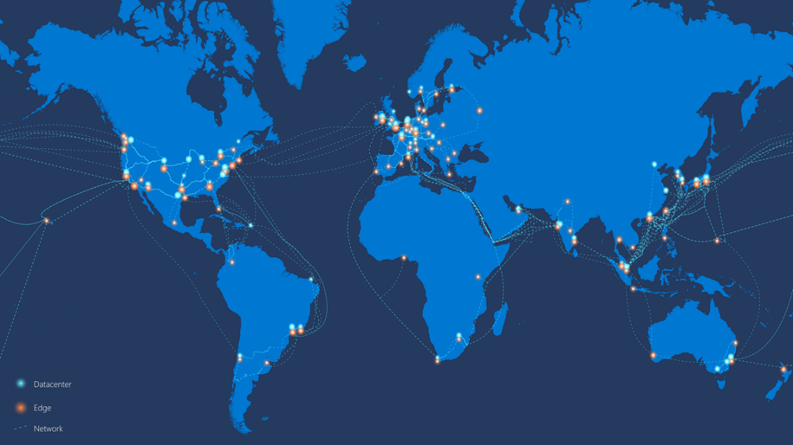

Azure Geographies

Azure Geographies are the topmost logical grouping in Microsoft Azure’s global infrastructure. Each geography represents a specific country or continent-sized area, designed to meet data residency, compliance, and sovereignty requirements.
Microsoft organizes its data center regions into geographies to ensure that:
- Customer data stays within a defined boundary
- Services comply with local laws and regulations
- Organizations have disaster recovery options across multiple regions within the same geography

🔹 Key Characteristics of Azure Geographies:
- Each geography contains two or more Azure Regions
- All regions within a geography are connected through low-latency, high-capacity network links
- Azure ensures data replication across regions in a geography to support business continuity
- Common geographies include:
  - United States
  - India
  - European Union
  - Asia Pacific
  - Middle East and Africa
The India Geography includes Azure regions such as Central India, South India, and West India — allowing Indian customers to meet data localization laws while enabling redundancy between regions.

“Geographies are foundational to Azure’s global strategy, enabling customers to meet legal, compliance, and business continuity goals.” — Microsoft Learn [1]

Azure Regions

An Azure Region is a set of data centers deployed within a specific geographic area, connected through a low-latency, high-bandwidth network. Each region is a fully independent deployment area for Azure services, offering customers the ability to run applications closer to their users, ensure data residency, and build highly available workloads.
Azure currently operates in 60+ regions across the globe, more than any other cloud provider, giving organizations unmatched flexibility to deploy resources in strategic locations.

Region Name | Location | Paired With
East US | Virginia, USA | West US
Central India | Pune, India | South India
West Europe | Netherlands | North Europe
Southeast Asia | Singapore | East Asia (Hong Kong)

🔹 Key Characteristics of Azure Regions:
- A region typically contains at least two data centers (or more)
- Regions are designed for high availability, often paired with another region for disaster recovery (e.g., East US ↔ West US)
- Each region offers a subset or all of Azure services, depending on local demand, compliance, and infrastructure maturity
- Some regions support Availability Zones for even higher resiliency

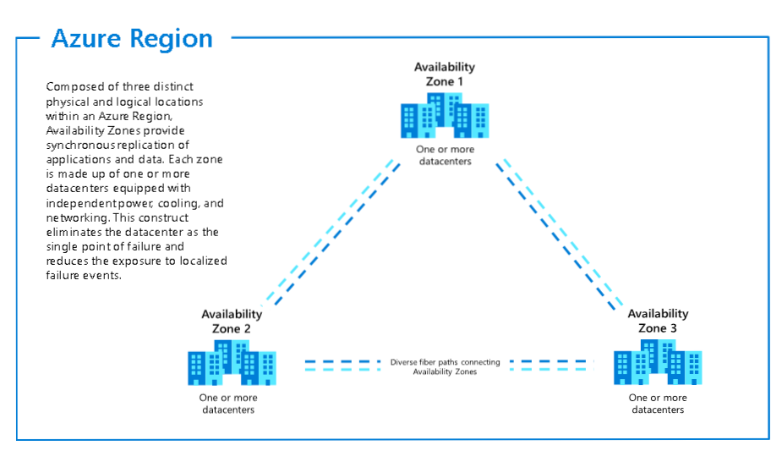

Availability zones

Availability Zones (AZs) are physically separate locations within a single Azure region, designed to provide high availability and fault isolation. Each Availability Zone is made up of one or more independent data centers, each with its own power, cooling, and networking.
AZs help protect applications and data from data center failures, making them ideal for mission-critical workloads that require redundancy and minimal downtime. If one zone goes down due to a hardware failure, fire, or network outage, the others continue functioning normally.

🔹 Key Features of Availability Zones:
- Physically isolated: Separate power, network, and cooling
- Low-latency, high-speed connectivity between zones
- Support for zone-redundant and zone-aware services (e.g., VMs, databases, load balancers)
- Automatically replicates data and traffic to maintain uptime

Example:
In the East US 2 region, Azure has three availability zones. You can deploy your app backend in Zone 1, database in Zone 2, and load balancer across all three — ensuring uptime even if one zone fails.

Use Cases for AZs:
- Hosting high-availability web applications
- Building disaster-resilient databases (e.g., Azure SQL with zone redundancy)
- Deploying HA Kubernetes clusters (Azure Kubernetes Service with multiple zones)
- Ensuring zero-downtime deployments

“Availability Zones are Azure’s promise of fault tolerance and reliability within a region — helping you meet both performance and uptime requirements.” — Microsoft Learn [1]

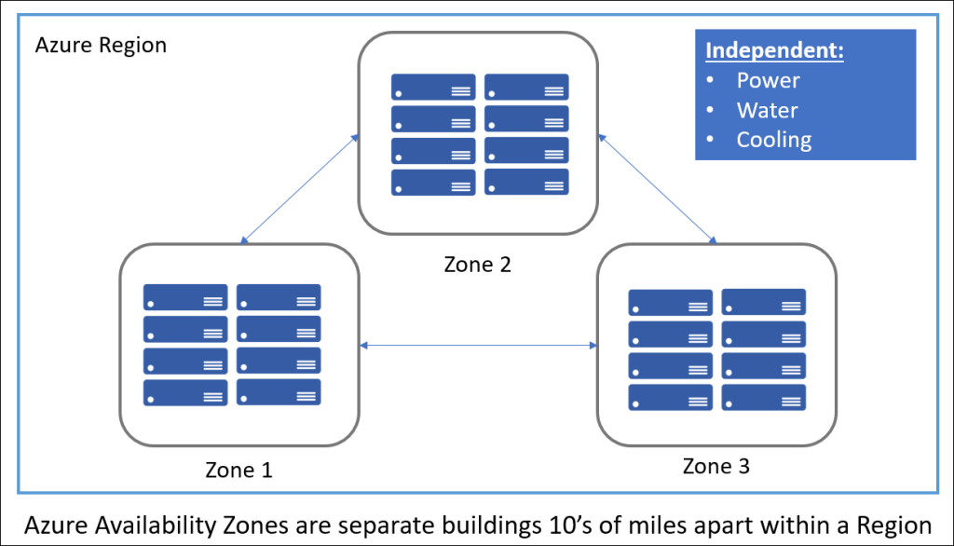

Azure Data Centers

Azure Data Centers are the physical buildings where Microsoft hosts the servers, storage systems, and networking hardware that power all Azure services. These data centers are the foundation of Azure’s global infrastructure and are distributed across hundreds of locations worldwide.
Each Azure data center is equipped with:
- Redundant power and cooling systems
- Physical security (biometric access, CCTV, mantraps)
- Advanced fire suppression and disaster protection systems
- Energy-efficient design, often powered by renewable energy sources
Data centers are grouped into regions, and in some cases, availability zones, enabling Microsoft to deliver services with low latency, high reliability, and geographic compliance.

🔹 Key Characteristics of Azure Data Centers:
- Built for scalability and sustainability
- Operate using custom-designed server hardware
- Monitored 24/7 by Microsoft’s global operations teams
- Linked by Microsoft’s private global fiber network, spanning over 280,000 km

📌 Notable Facts:
- Microsoft has over 200 data centers in operation
- Each facility may host thousands of servers
- Azure uses edge data centers to cache content closer to users for improved performance
- Facilities are designed to meet ISO, SOC, GDPR, and other compliance standards

Global Redundancy and Resiliency Strategy

Microsoft Azure’s global infrastructure is not just built for scale — it's designed for resilience. This means that even if failures occur at the hardware, data center, or regional level, Azure services can continue to operate with minimal disruption.
Azure achieves this through a multi-layered redundancy strategy, combining Availability Zones, Region Pairing, automated failover, and geo-replication to ensure data durability and application uptime.

🔹 Key Components of Azure’s Resiliency Model:
- Availability Zones (AZs):
Provide protection from data center-level failures within a region. Apps and databases can be deployed redundantly across AZs to survive localized outages.
- Region Pairs:
Every Azure region is paired with another in the same geography (e.g., East US ↔ West US), and Microsoft ensures:
  - Updates are rolled out one region at a time
  - Automatic failover is possible
  - Geo-replication for services like Azure Storage and Azure SQL
- Geo-Redundancy:
Critical services support GZRS (Geo-Zone-Redundant Storage) or Geo-Redundant Backups to replicate data across regions.
- Service-Level Agreements (SLAs):
Microsoft provides uptime guarantees of 99.9% to 99.999% for many zone-redundant services.

📌 Example Scenario:
A business running an e-commerce app in Southeast Asia with zone-redundant databases and cross-region failover can maintain full uptime even if an entire zone or region becomes unavailable.

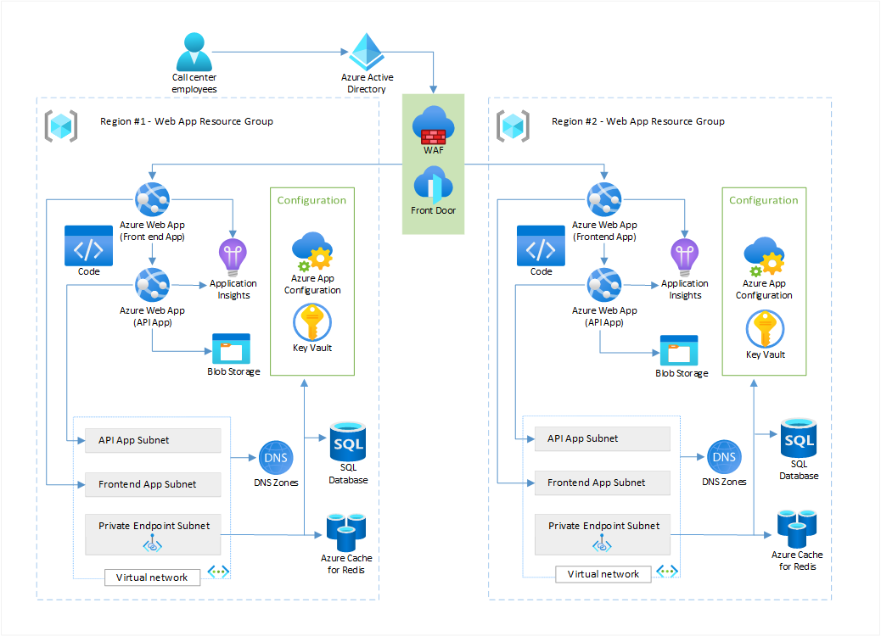

Real-World Relevance in Cloud Deployments

Azure’s global infrastructure is designed not only for scalability and performance but also for addressing the diverse needs of businesses operating in today’s complex digital environment. Whether an organization is deploying a small web application or managing enterprise-wide digital transformation, understanding the structure and strategy behind Azure’s infrastructure is essential for ensuring resilience, compliance, and efficiency.
Each component of Azure’s infrastructure—geographies, regions, availability zones, and data centers—plays a vital role in meeting specific business requirements such as data sovereignty, service continuity, and user experience optimization.

Key Real-World Applications:
- Data Residency and Compliance
Organizations subject to regulatory standards (e.g., GDPR, HIPAA, RBI guidelines) can select Azure geographies and regions that ensure data is stored and processed within legally approved boundaries.
- High Availability Architectures
Businesses with critical applications use availability zones within a region to achieve fault tolerance, minimizing downtime during localized infrastructure failures.
- Latency Optimization
Applications can be deployed in regions geographically close to the user base, significantly reducing response time and improving performance for global customers.
- Disaster Recovery and Business Continuity
By leveraging region pairs and geo-redundant services, organizations can build robust disaster recovery strategies that ensure continuity in the face of regional outages.
- Hybrid and Distributed Deployments
Azure’s extensive global network facilitates seamless integration between on-premises environments and cloud services, supporting hybrid cloud, multi-region, and multi-cloud strategies.

Understanding and applying the principles of Azure’s infrastructure allows organizations to design cloud architectures that are not only technically sound but also aligned with long-term operational and regulatory goals.
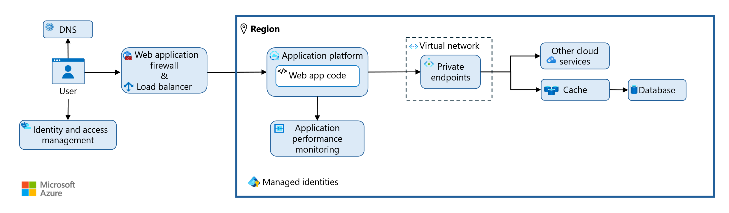

Conclusion
Microsoft Azure’s global infrastructure is engineered to deliver secure, scalable, and high-performance cloud services across the globe. Through its layered architecture — comprising Geographies, Regions, Availability Zones, and Data Centers — Azure empowers organizations to meet critical business needs such as regulatory compliance, data residency, disaster recovery, and low-latency user experiences.Each component plays a distinct and essential role:
- Geographies address legal and jurisdictional boundaries,
- Regions provide flexible deployment locations,
- Availability Zones ensure fault tolerance and high availability, and
- Data Centers serve as the operational backbone of Azure’s services.
This infrastructure enables businesses to deploy applications confidently and securely, no matter their size, industry, or location. Whether building a simple web app or architecting a global enterprise solution, understanding Azure’s infrastructure equips professionals to design robust, resilient, and compliant cloud systems.
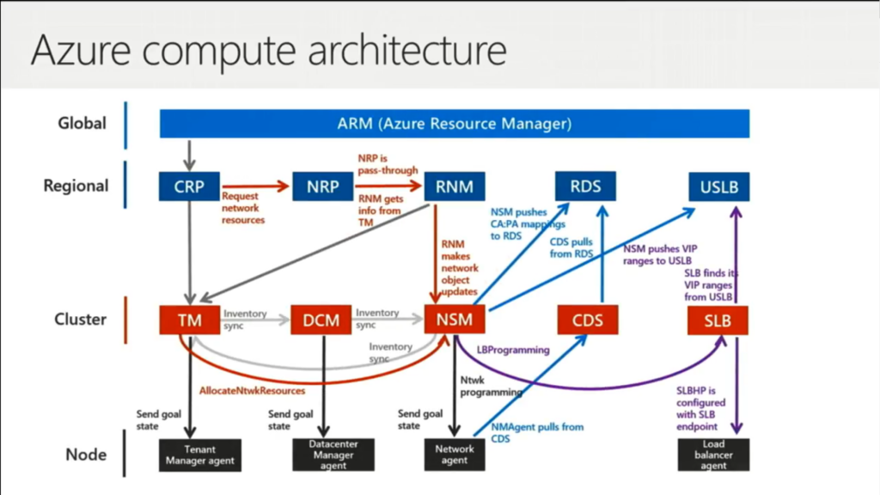
As digital transformation accelerates, a solid grasp of these foundational elements becomes not just valuable, but essential for building and managing the future of cloud technology.

Reference

[1] Microsoft. (2024).
https://datacenters.microsoft.com/globe/the-building-blocks-of-azure/
Global network: https://learn.microsoft.com/en-us/azure/networking/microsoft-global-network

